Design Document Stock Control.

In Partial Fulfillment for a Higher Diploma in Computer
Science.

Student: TJ Fitzpatrick.

Student Number: C00210561.

Supervisory Committee:
Tim Casey.
Keara Barrett.
Noel O’Hara.
Caroline Byrne.

Table of Contents.
Table of Contents. 2
Table of Figures. 3
1. Introduction. 4
1.1 Purpose. 4
1.2 Scope. 4
2. System Overview. 5
2.1 System Characteristics. 5
2.2 System Architecture. 5
2.3 Infrastructure Services. 5
3. Software development. 6
3.1 Software Development Tools. 6
3.1.1 Notepad++. 6
3.1.2 Google Chrome. 6
3.1.3 Html. 6
3.1.4 Javascript. 6
3.1.5 Css. 6
3.1.6 Php. 6
3.1.7 MySql. 6
3.2 Software Storey Boards. 7
3.2.1 Index Page. 7
3.2.2 Login Page. 7
3.2.3 Manager Mode. 8
3.2.4 Staff Mode. 9
3.3 Software Flow Diagrams. 10
3.3.1 Index Page. 10
3.3.3 Manager Mode. 11
3.3.4 Staff Mode. 12

Table of Figures.
Figure 1 - Mode Select. 7
Figure 2- Login Page. 7
Figure 3 - Manager Mode. 8
Figure 4 - Staff Mode. 9
Figure 5 index Page Flow Diagram. 10
Figure 6 Login Page. 11
Figure 7 - Manager Page. 11
Figure 8 - Staff Page. 12

Introduction.

Purpose.
The purpose of this document is to provide a description of the design process in designing a stock control system for a bar, this document is basically the0 specification, it will specify what steps have to be completed in order to document stock take in a bar.
Stock takes are important to every bar, a stock take allows business owners to see what stock is in house and what stock will have to be ordered, it also allows business analysists to see different trends and help them predict the upcoming market.

Scope.
Stock taking software must be designed and implemented for the “Halona House” bar.
The Halona house bar has 3 full time staff which includes the owner, and 4-part time staff that work the weekend.
There are two managers one for day shifts and one for night shifts, regardless of the shift there is either a manager working or the owner is working.
After a busy day mistakes are often made by staff when re stocking fridges, these mistakes can be seen as the amount of stock to be stocked and the amount of stock sold do not match.
On a monthly manual stock take it can be seen that there is stock missing, more often than not misplaced in the stock room or allowed to be borrowed by other bars without returning it.
Stock must be accounted for weather or not it is borrowed and not payed back this costs the business money.

System Overview.

2.1 System Characteristics.
The system must have two different interfaces, one for regular staff and another for managers.
Managers must control the stock movements within the bar, this means stock being borrowed and returned, also managers must be able to add new people to the system, not just staff but managers also, the bar regurly buys its long term customers a complimentary product on special occasions but only managers may be able to do this.
For unhappy customers there must be a refund available, this can only be done by managers also.
Reports must be generated at the end of each day that say how much was sold, who it was sold by and what time it was sold, each day sales and a profit sheet must be generated, this sheet will tell managers how much was made at the end of each shift.

2.2 System Architecture.
In order for the system to document and record sales a my SQl database must be used, this database will document and store all information for a two-year period.
In order for a database to be used an interface must be put onto it, for this interface html will be used.
Benefits of this include a manager will be able to log on at any period in time and see what products have sold and busy the business is during the day period.

2.3 Infrastructure Services.
Services that will have to be implemented as follows:
- Add / delete product.
- Product sale, by date and time.
- Add user / remove user.
- Deliveries in Date and time documented.
- Borrowed stock in / Borrowed Stock out.
- Monthly stock sold.
- Yearly stock sold.
- Waste management.
- Profit and Loss.
- Trend Analysis.
- Orders to be made.
- Staff Roster And Wages Due.

Software development.

3.1 Software Development Tools.
Software used to develop code include:
- Notepad++.
- Google Chrome.
- Html.
- Javascript.
- Css.
- Php.
- MySql.

3.1.1 Notepad++.
Notepad++ is a free and open source text editor, within this editor many languages are supported including C, C++, Html, Css, Java, Javascript, Php, mySql, ect.
It has built in tabbed editing and allows support for multi windows.

3.1.2 Google Chrome.
Google chrome is a free and open source web browser supplied by google.inc.

3.1.3 Html.
Html stands for Hyper Text mark-up language and is a language used to display web content on the Internet.

3.1.4 Javascript.
Javascript is a scripting language designed to execute on a web page once the page loads.

3.1.5 Css.
CSS stands for cascaded style sheet and is used to style a Html web page.

3.1.6 Php.
PHP is a widely-used open source general-purpose scripting language that is especially suited for web development and can be embedded into HTML.

3.1.7 MySql.
MySql is a database management system.
It is this system that will hold all data associated with the project.

3.2 Software Storey Boards.

3.2.1 Index Page.
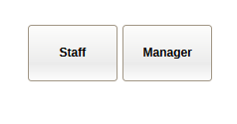
Figure 1 - Mode Select.
When the user receives the index page they must choose which mode they would like to log into, manager or staff mode.
Once clicking the button, they will be re directed to a login page.

3.2.2 Login Page.
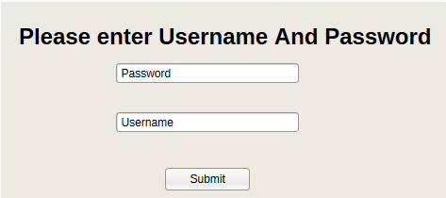
Figure 2- Login Page.

3.2.3 Manager Mode.
Once logged into manager mode the manager will have access to all reports, add and delete staff, and also add and delete products.
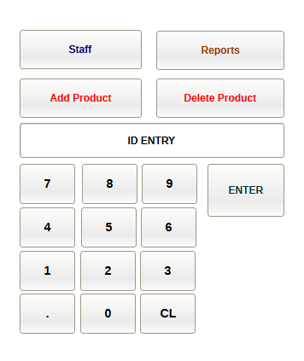
Figure 3 - Manager Mode.

3.2.4 Staff Mode.
Once logged into Staff mode the employee can enter products they have sold and it will alter the database.

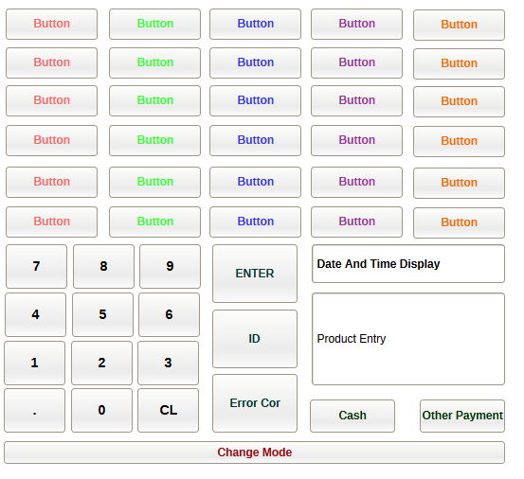
Figure 4 - Staff Mode.

3.3 Software Flow Diagrams.

3.3.1 Index Page.

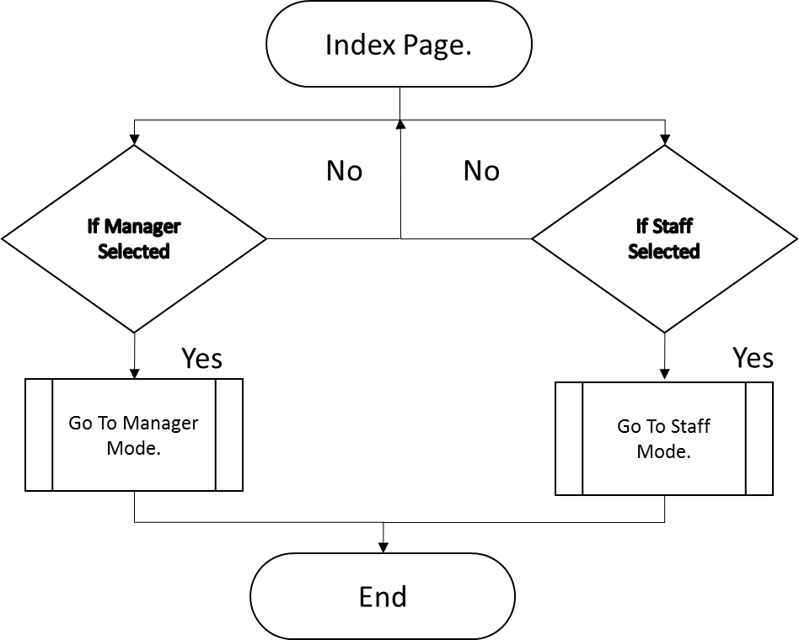
Figure 5 index Page Flow Diagram.

3.3.2 Login Page.
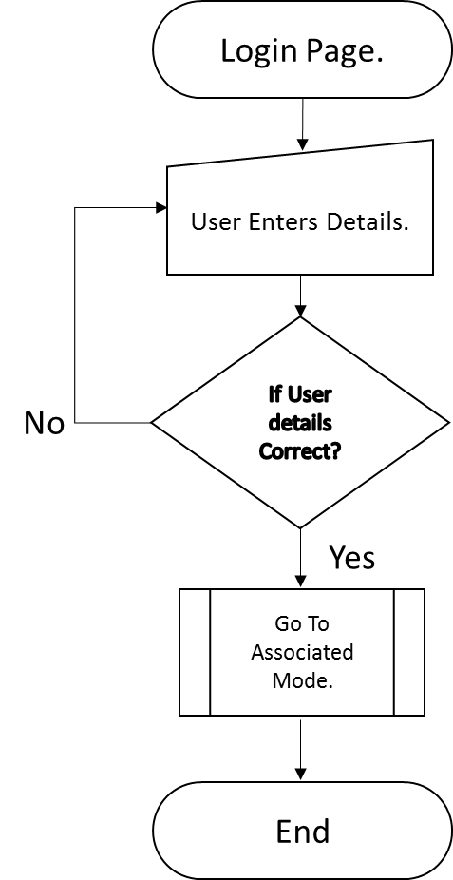
Figure 6 Login Page.

3.3.3 Manager Mode.

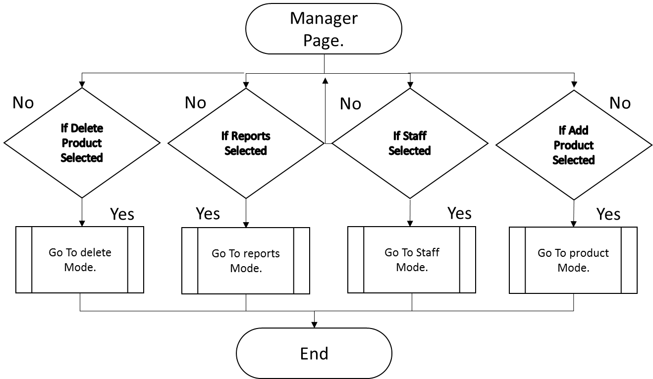
Figure 7 - Manager Page.

3.3.4 Staff Mode.

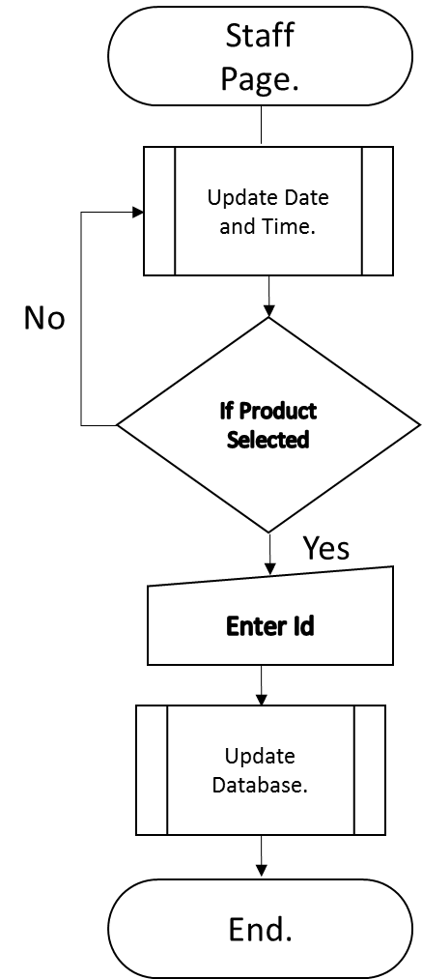
Figure 8 - Staff Page.

